AUTOMATED WATER IRRIGATION SYSTEM
Mrs. Priyadharshini¹ Assistant Professor Dept. of Information Technology Velammal Engineering College Chennai,India @velammal.edu.in
Manova Daniel²
Dept.of Information Technology
Velammal Engineering College
Chennai, India
jmanovadaniel.11@gmail.com
Hariharan B³
Dept.of Information Technology
Velammal Engineering College
Chennai, India
bsangeetha359@gmail.com

Sivaramakrishnan R⁴
Dept. of Information Technology
Velammal Engineering College
Chennai, India
sivaramakrishnanr29@gmail.com
Rahul Kumaran R⁵
Dept. of Information Technology
Velammal Engineering College
Chennai. India
rahulprajith005@gmail.com

Abstract:Agriculture plays a vital role in sustaining the global economy, and efficient water management is crucial for maximizing crop yield while minimizing resource wastage. Traditional irrigation methods often lead to excessive water usage or under-irrigation, negatively impacting crop growth. An Automated Water Irrigation System utilizing temperature, humidity, and soil moisture sensors provides a smart solution to optimize water usage in agricultural fields.
This system employs IoT-based sensors to continuously monitor environmental parameters such as soil moisture content, ambient temperature, and humidity levels. A microcontroller unit (MCU) processes the collected data and determines the precise irrigation requirements. When soil moisture falls below a predefined threshold, the system automatically activates the water pump to irrigate the field until the required moisture level is restored. The system can also be integrated with wireless communication and cloud technology, allowing remote monitoring and control via a mobile application or web interface.
By implementing such an automated approach, the system ensures efficient water utilization, reduces manual labor, and enhances crop productivity. It is particularly beneficial in drought-prone regions, where water conservation is critical. Additionally, integrating AI and Machine Learning algorithms can further optimize irrigation scheduling based on predictive analysis of weather patterns and soil conditions.
This smart irrigation system represents a step towards sustainable agriculture, promoting resource efficiency and improving overall farm management through automation and technology.

I. INTRODUCTION
Water is a crucial resource for agriculture, and its efficient management is essential for maximizing crop yield while conserving water. Traditional irrigation methods, such as manual watering or scheduled irrigation, often lead to water wastage or inadequate irrigation, negatively affecting crop health. To address this issue, automated irrigation systems utilizing temperature, humidity, and soil moisture sensors have been developed to optimize water usage in agricultural fields.
An Automated Water Irrigation System integrates Internet of Things (IoT) technology, microcontrollers, and various environmental sensors to monitor real-time conditions of the soil and atmosphere. These sensors collect data on temperature, humidity, and soil moisture, which is then processed by a microcontroller or an embedded system to determine when irrigation is needed. When the soil moisture level drops below a predefined threshold, the system automatically activates the water pump and stops it once the required moisture level is reached. This approach ensures that plants receive the necessary amount of water without human intervention, leading to efficient water management and improved crop productivity.
The integration of wireless communication and cloud-based platforms enables remote monitoring and control of the irrigation system through a mobile application or web interface. Furthermore, artificial intelligence (AI) and machine learning algorithms can be incorporated to analyze past data and predict irrigation schedules based on weather conditions, further enhancing efficiency.
This smart irrigation system is particularly beneficial in regions facing water scarcity and helps farmers reduce operational costs, save water, and increase agricultural output. By leveraging automation and real-time data analytics, this system contributes to the development of sustainable and technology-driven agriculture, ensuring optimal resource utilization and environmental conservation.

II. LITERATURE SURVEY
The development of automated water irrigation systems using temperature, humidity, and soil moisture sensors has been extensively studied in recent years due to the increasing demand for efficient water management in agriculture. Several research studies and technological advancements have contributed to the evolution of smart irrigation systems.
1. IoT-Based Smart Irrigation Systems
Recent studies highlight the role of Internet of Things (IoT) in modern irrigation systems. According to Patel et al. (2021), IoT-based irrigation systems use wireless sensor networks (WSN) to collect real-time environmental data, which is transmitted to a cloud-based platform for analysis. This enables farmers to monitor and control irrigation remotely, reducing manual effort and improving efficiency.
2. Sensor-Based Irrigation Techniques
Several researchers, including Kumar et al. (2020), have explored the integration of soil moisture, temperature, and humidity sensors in irrigation systems. Their studies indicate that soil moisture sensors significantly enhance water conservation by reducing unnecessary irrigation cycles and maintaining optimal soil conditions. The combination of temperature and humidity sensors allows the system to adjust water supply based on environmental conditions, preventing overwatering or underwatering.

3. Machine Learning and AI in Irrigation
The application of artificial intelligence (AI) and machine learning (ML) has been a recent trend in automated irrigation. According to Gupta et al. (2022), AI-driven irrigation systems analyze historical weather data, soil moisture levels, and crop requirements to predict the best irrigation schedule. ML algorithms, such as decision trees and artificial neural networks (ANNs), improve system accuracy by learning from past irrigation patterns.
4. Energy-Efficient Irrigation Models
Energy consumption is a critical factor in irrigation automation. Studies by Sharma et al. (2019) have investigated the use of solar-powered automated irrigation systems. These systems integrate solar panels with microcontroller-based irrigation models, making them sustainable and cost-effective, especially in remote agricultural regions with limited electricity access.
5. Comparative Studies on Traditional vs. Automated Irrigation
Several comparative analyses, including those by Rao et al. (2018), demonstrate that automated irrigation systems reduce water consumption by 30-50% compared to traditional methods. Their studies emphasize that automated systems not only enhance crop yield but also contribute to sustainable farming practices by minimizing water wastage.

III. PROPOSED WORK
The IoT-based smart irrigation automated system proposed is to optimize the use of water in agriculture through the integration of sensor networks, cloud computing, and automation techniques. The system employs temperature sensors, humidity sensors, and water level sensors that feed real-time information from the field. The information is transmitted via a cloud-based server through an IoT gateway, where smart algorithms analyze it to decide the optimal irrigation schedule.
A microcontroller unit (MCU) like an Arduino or Raspberry Pi serves as the system's central processing unit, which commands solenoid valves to alter water flow based on sensor readings. The system utilizes machine learning algorithms to consider past weather readings to enhance irrigation efficiency in the long term. A mobile app or web interface is also created to enable farmers to monitor the system in real-time and exercise remote control.
In order to control water in a sustainable way, the system uses weather forecast information retrieved from web APIs to predict rain and determine irrigation schedules based on that. Low-power wide-area networks such as LoRa or NB-IoT are used to offer power-efficient long-range communication between field sensors and the cloud platform.

The proposed system assists in sustainable agriculture by conserving water, minimizing human intervention, and maximizing crop yield using data-driven irrigation management. Usage is expected to make a significant difference in enhancing the utilization of resources and reducing the operational cost for farmers.

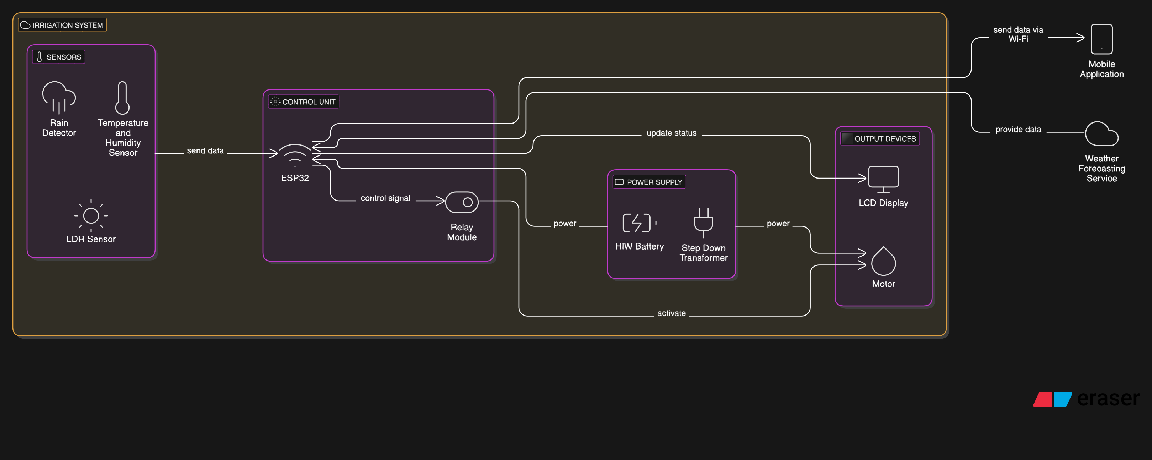
Figure1. System Architecture
Key Components and Features
1. ESP32-C3 Microcontroller (Core Processing Unit)
- Acts as the central control unit of the entire system.
- Comes with built-in Wi-Fi and Bluetooth, enabling wireless IoT communication.
- Supports low-power operation, making it suitable for remote and energy-efficient deployment.
- Handles data processing and decision-making based on sensor inputs.

2. DHT11 Sensor (Temperature and Humidity Monitor)
- Measures ambient temperature and relative humidity in real-time.
- Provides crucial environmental data to help determine the ideal irrigation schedule.
- Supports data-driven irrigation for better crop health and water efficiency.

3. Rainfall Sensor Module
- Detects the presence of rainfall through conductivity changes.
- Automatically disables irrigation during or after rainfall to prevent overwatering.
- Enhances water conservation and system intelligence.

4. Relay Module (Pump/Solenoid Control)
- Serves as an electronic switch that controls the activation of pumps or solenoid valves.
- Enables automatic ON/OFF control of irrigation components based on sensor data.
- Electrically isolates the control circuit from the high-voltage pump system for safety.

5. 16x2 LCD Display (User Interface)
- Displays real-time data including temperature, humidity, rain status, and system activity.
- Acts as a local feedback interface for farmers without smartphone access.
- Useful for testing, monitoring, and operational control in the field.

6. Water Level Sensor
- Measures the level of water available in the irrigation tank or reservoir.
- Prevents pump activation when water is below a certain threshold, protecting the pump from dry run conditions.
- Helps in managing water resources efficiently.

7. LED Indicators
- Provide visual feedback on the status of sensors, relay module, and water pump.
- Helps in real-time diagnostics and monitoring during both development and deployment.
- Enhances ease of use and system transparency.

8. Mobile Application Interface
- Allows users to monitor sensor data and control the irrigation system remotely via smartphone.
- Displays real-time temperature, humidity, rain detection, and motor status.
- Supports manual override and enhances accessibility for farmers even from remote locations.

9. Power Supply and Voltage Regulation Circuit
- Provides stable 5V power to all components using regulated sources like batteries or adapters.
- Protects the components from voltage fluctuations and ensures reliable operation.
- Enables deployment in off-grid areas when used with battery or solar power.

Comparative Analysis Table:
Performance  Metric | Traditional  Irrigation | Soil  Moisture | Proposed  Weather
Water Usage  Efficiency | Low | Moderate | High
Automation  Level | Manual | Semi  Automated | Fully  Automated
Sensor  Dependency | None | High | Low
Weather  Adaptability | None | Low | High
Maintanance  Requirement | Low | High | Low
Installation Cost | Low | Moderate | Moderate
User Control and  Monitoring | None | Limited | Real Time
Environmental  Sustainability | Low | Moderate | High

System Flow Diagram:
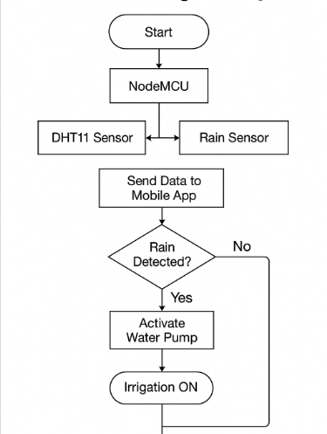

III. CONCLUSION AND FUTURE IMPROVEMENTS
The proposed IoT-based automated water irrigation system is a smart, data-driven solution designed to optimize agricultural water usage by integrating real-time environmental monitoring, intelligent control, and remote accessibility. Utilizing the ESP32-C3 microcontroller, the system efficiently manages irrigation through temperature, humidity, rain, and water level sensors, coupled with automated pump control using a relay module. The inclusion of a user-friendly interface via LCD display and mobile application empowers farmers to monitor and control irrigation from anywhere, reducing human intervention while enhancing operational efficiency.
Future improvements to the system include the integration of soil moisture sensors for more precise irrigation control based on root-zone data, and the incorporation of predictive analytics using historical weather data and cloud-based machine learning models to fine-tune irrigation schedules. A cloud dashboard can also be developed for long-term data logging, crop analytics, and visual reports. Furthermore, the system could be expanded to support solar power integration, enhancing its sustainability and usability in remote or off-grid farming regions.
With these advancements, the smart irrigation system aims to further increase water conservation, reduce labor costs, and support sustainable agriculture, demonstrating the transformative role of IoT and automation in modern farming practices.

IV. REFERENCES
[1] Kumar, V. V., Ramasamy, R., Janarthanan, S., & VasimBabu, M. (2017). "Implementation of IoT in Smart Irrigation System Using Arduino Processor." International Journal of Civil Engineering and Technology, 8(10), 1304–1314.
[2] Raut, S. S., & Rane, S. M. (2017). "Smart Irrigation System with IoT." International Journal of Advance Research, 2(2), 299–304.
[3] Kavitha, V., & Kumar, K. (2020). "Smart Irrigation System Using IoT Technology." International Journal of Advanced Science and Technology, 19(14).
[4] Li, X., Peng, S., & Chen, Y. (2021). "Smart Irrigation System Using IoT and Machine Learning Algorithms."
[5] Zaman, M., Rahman, M., & Islam, M. (2020). "Smart Irrigation System." International Journal of Scientific & Engineering Research, 11(10). [6] Mansi Kashyap, Shuchita Saxena, Shivani Agarwal, Rohini Singh, "REVIEW ON CHILD SAFETY WEARABLE DEVICES". 2020 International Journal of Scientific Research and Management Studies (IJSRMS),
ISSN: 2349-3771 Volume 4 Issue 3.
[6] Saini, S. S., Narender, N., & Kumar, V. (2018). "Design and Implementation of a Smart Irrigation System Using IoT Technology." International Journal of Computer Science and Information Security, 16(4).
[7] Aydin, Ö., Kandemir, C. A., Kiraç, U., & Dalkiliç, F. (2021). "An Artificial Intelligence and Internet of Things Based Automated Irrigation System."
[8] Pargo, T. A., Shirazi, M. A., & Fadai, D. (2025). "Smart and Efficient IoT-Based Irrigation System Design: Utilizing a Hybrid Agent-Based and System Dynamics Approach."

[9] Binayao, R. P., Mantua, P. V. L., Namocatcat, H. R. M. P., Seroy, J. K. K. B., Sudaria, P. R. A. B., Gumonan, K. M. V. C., & Orozco, S. M. M. (2024). "Smart Water Irrigation for Rice Farming through the Internet of Things."

[10] Karar, M. E., Al-Rasheed, M. F., Al-Rasheed, A. F., & Reyad, O. (2020). "IoT and Neural Network-Based Water Pumping Control System for Smart Irrigation." [14] Anand, M., Naseem, Z., Trivedi, S., Abhishek, Garg, P. (2023). “Design of a Novel Smart Device for Human Safety”. In: Jain, S., Marriwala, N., Tripathi, C.C., Kumar, D. (eds) Emergent Converging Technologies and Biomedical Systems. ETBS 2022. Lecture Notes in Electrical Engineering, vol 1040. Springer, Singapore. https://doi.org/10.1007/978-981-99-2271-0_52,
DOI: https://doi.org/10.1007/978-981-99-2271-0_52
[11] S. Raut, S. M. Rane, “Smart Irrigation System with IoT,” International Research Journal of Engineering and Technology (IRJET), Vol. 4, Issue 5, May 2017.
[ at: https://www.irjet.net/archives/V4/i5/IRJET-V4I581.pdf]
[12] R. P. Binayao et al., “Smart Water Irrigation for Rice Farming through the Internet of Things,” arXiv preprint, arXiv:2402.07917, 2024.
[https://arxiv.org/abs/2402.07917]
[13] C. A. Kandemir, Ö. Aydin, F. Dalkiliç, “An Artificial Intelligence and Internet of Things-Based Automated Irrigation System,” arXiv preprint, arXiv:2104.04076, 2021.
[https://arxiv.org/abs/2104.04076]
[13] Internet of things. https://en.wikipedia.org/wiki/Internet_of_things

